Date- 14/10/2023

Roll No. - 23

Expt. No. - 8

K.M.S.P. Mandal’s

Sant Rawool Maharaj Mahavidyalaya, Kudal

**Department of Computer Science**

Signature

Perform a forensic analysis of a mobile device, such as a smartphone or tablet & Retrieve call logs, text messages, and other relevant data for investigative purposes.

Title - _______________________________________________________

_______________________________________________________

**MOBILedit Forensic** is a [digital forensics](https://en.wikipedia.org/wiki/Digital_forensics) product by Compelson Labs that searches, examines and report on data from GSM/CDMA/PCS cell phone devices. MOBILedit connects to cell phone devices via an Infrared (IR) port, a [Bluetooth](https://en.wikipedia.org/wiki/Bluetooth) link, Wi-Fi, or a cable interface. After connectivity has been established, the phone model is identified by its manufacturer, model number, and serial number ([IMEI](https://en.wikipedia.org/wiki/IMEI)) and with a corresponding picture of the phone.

Data acquired from cell phone devices are stored in the .med file format. After a successful logical acquisition, the following fields are populated with data: subscriber information, device specifics, Phonebook, SIM Phonebook, Missed Calls, Last Numbers Dialed, Received Calls, Inbox, Sent Items, Drafts, Files folder. Items present in the Files folder, ranging from Graphics files to Camera Photos and Tones, depend on the phone’s capabilities. Additional features include the myPhoneSafe.com service, which provides access to the IMEI database to register and check for stolen phones.

**MOBILedit** is a platform that works with a variety of phones and [smartphones](https://en.wikipedia.org/wiki/Smartphones) (a complete list of supported handsets is available on the manufacturer’s website) and explores contents of the phone through a MS Outlook-like folder structure. This allows backup of the information stored on the phone, storing it on a PC or copy data to another phone via Phone Copier feature.

### ****Uses of Mobile Forensics:****

The military uses mobile devices to gather intelligence when planning military operations or terrorist attacks. A corporation may use mobile evidence if it fears its intellectual property is being stolen or an employee is committing fraud. Businesses have been known to track employees’ personal usage of business devices in order to uncover evidence of illegal activity. Law enforcement, on the other hand, may be able to take advantage of mobile forensics by using electronic discovery to gather evidence in cases ranging from identity theft to homicide.

### ****Process of Mobile Device Forensics:****

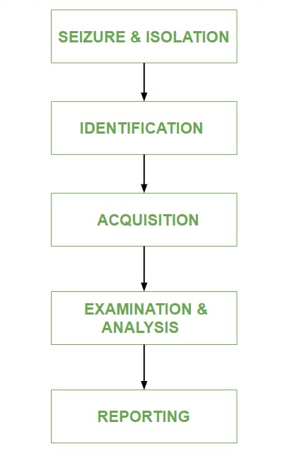

**MOBILedit interface**

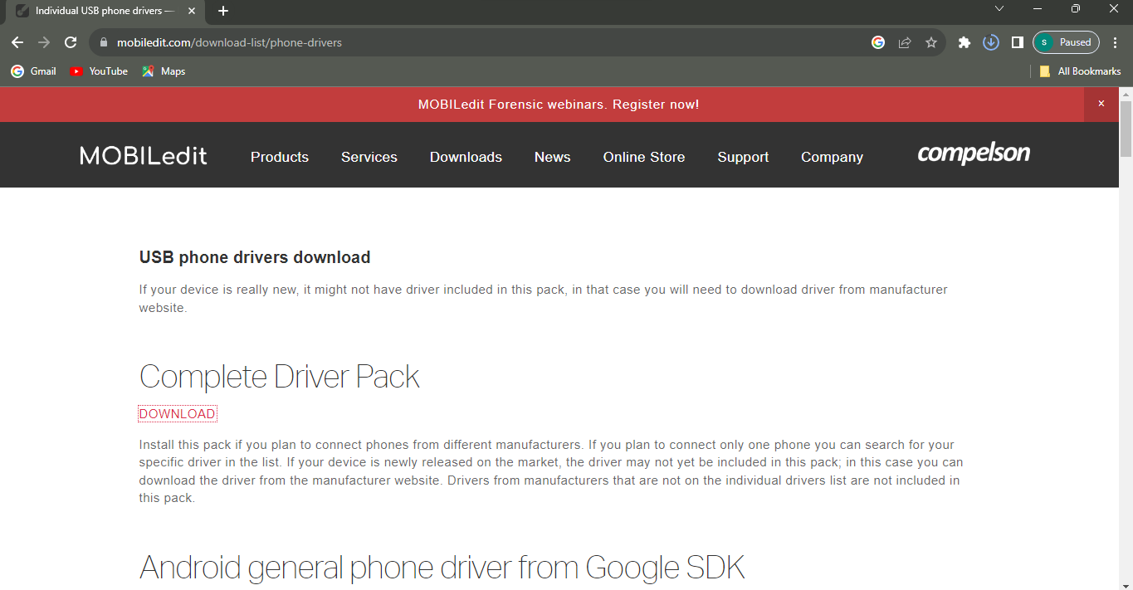

**Connect our phone to the MOBILedit**

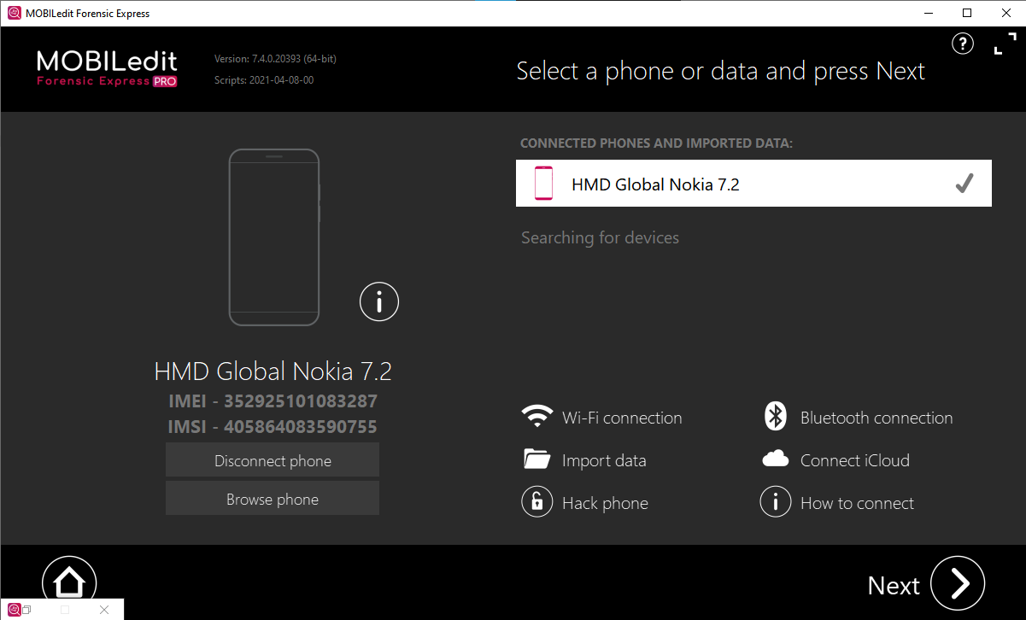

**Connector Installation**

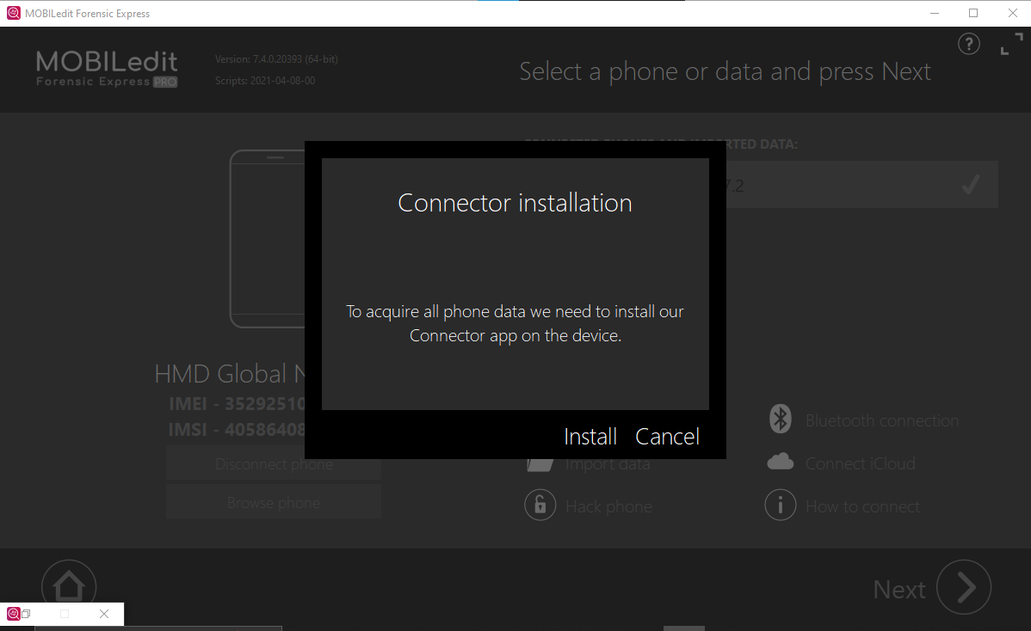

**Phone data peview**

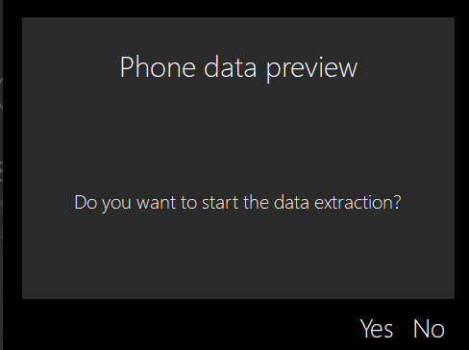

**Data Extraction**

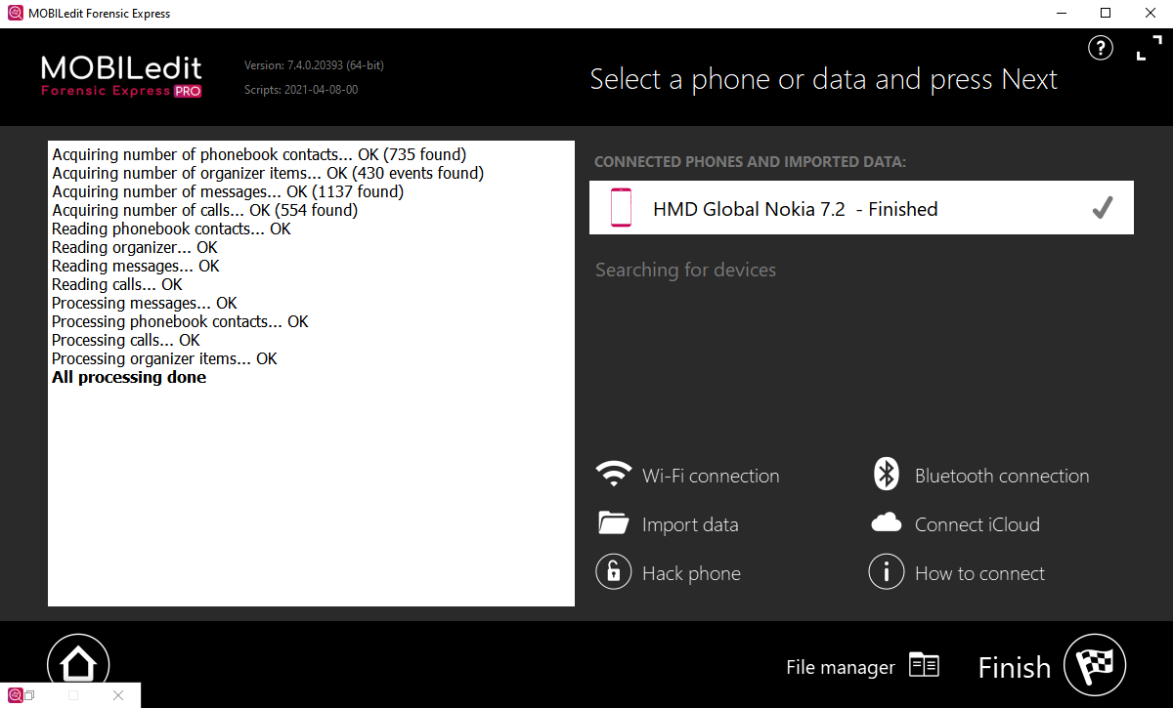

**Choose What to extract**

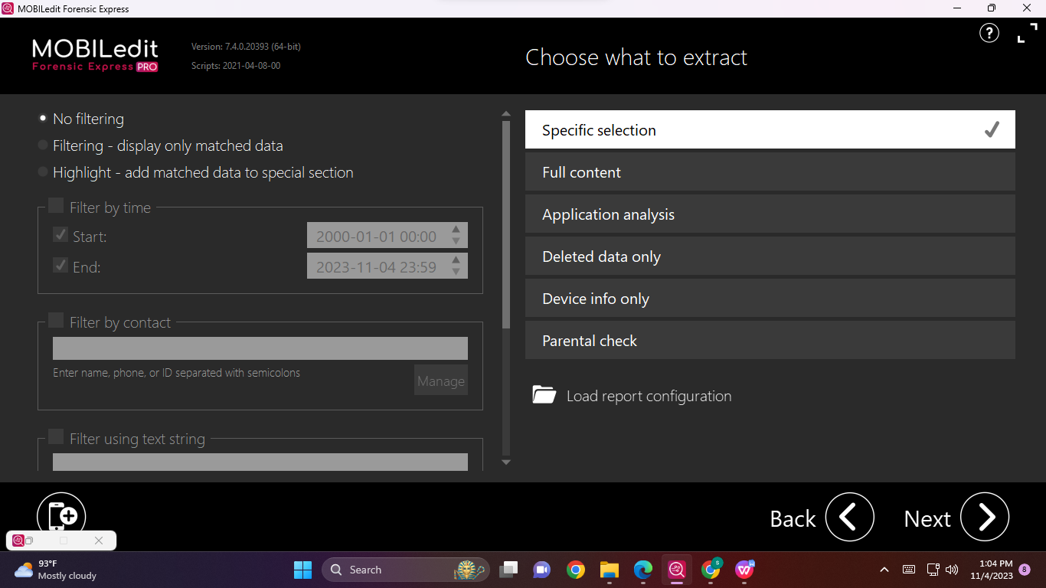

**Phonebook**

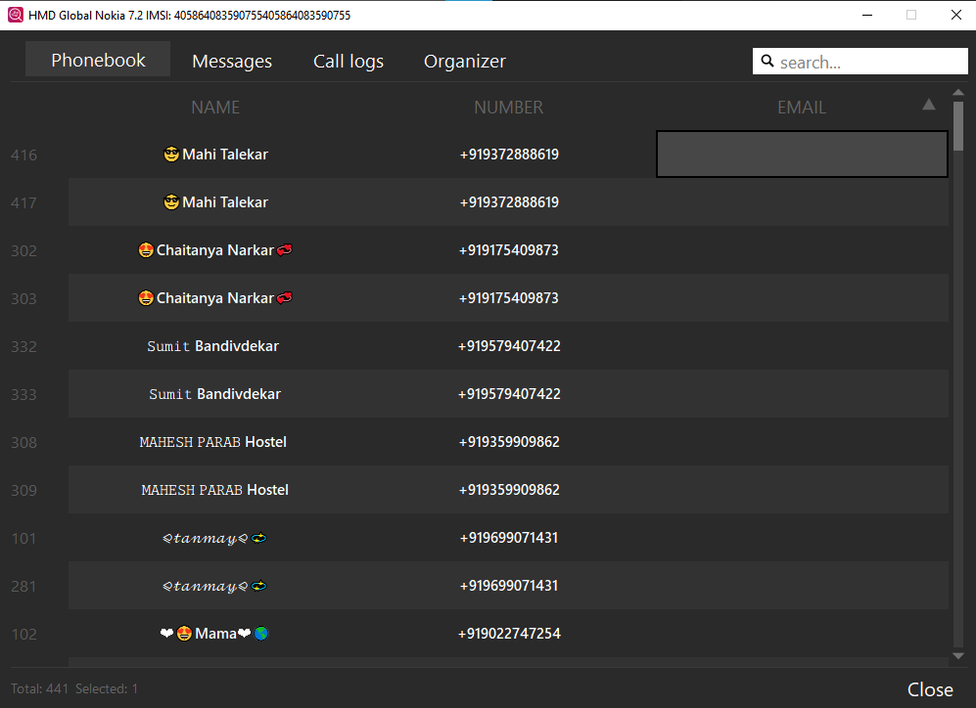

**Message**

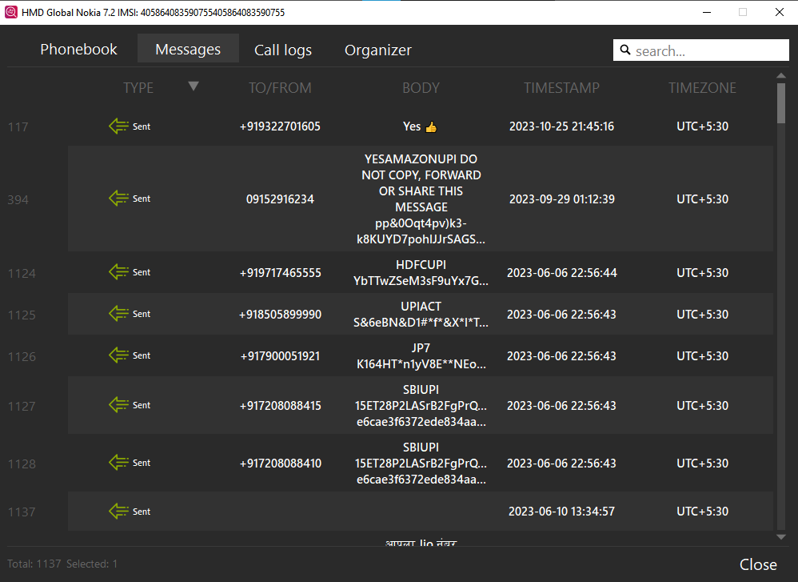

**Call Log**

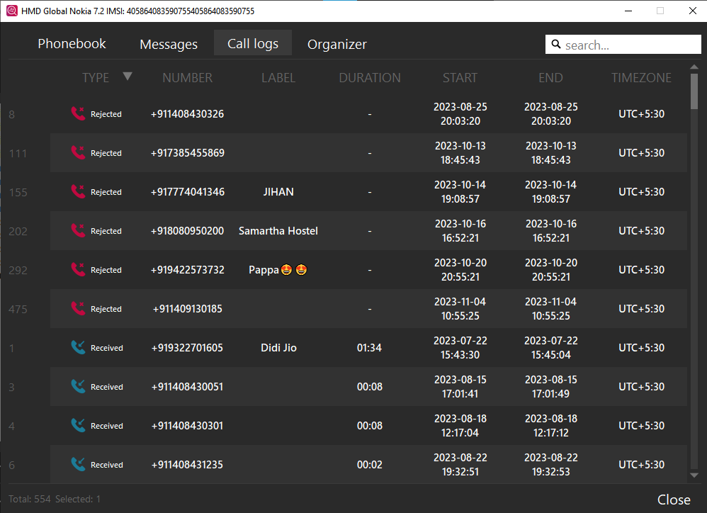

**Configure Your Report**

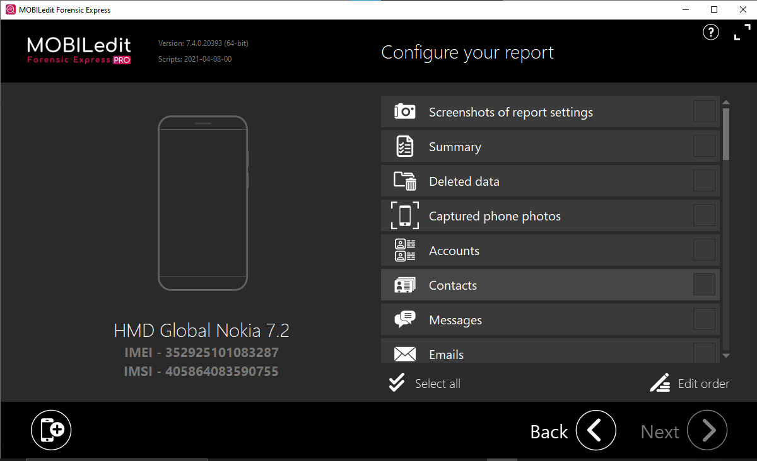

**Select**

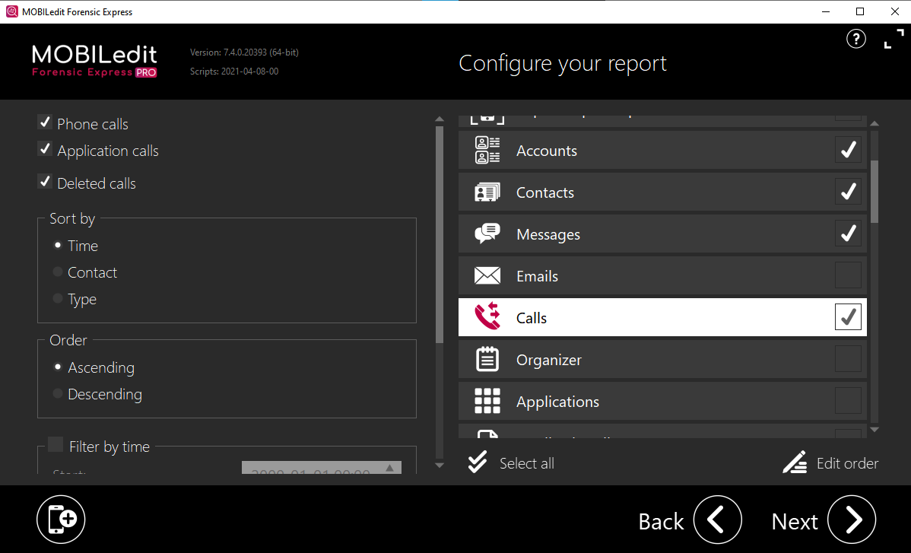

**Choose Report format**

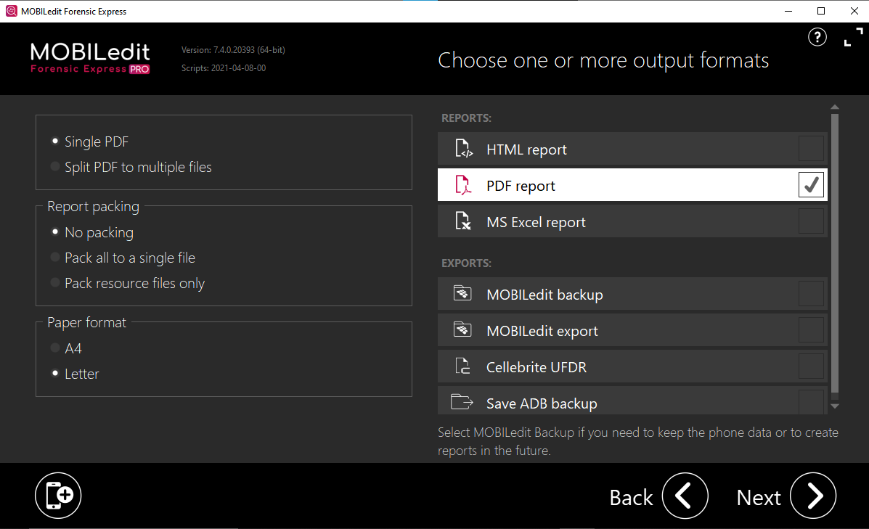

**Export Report**

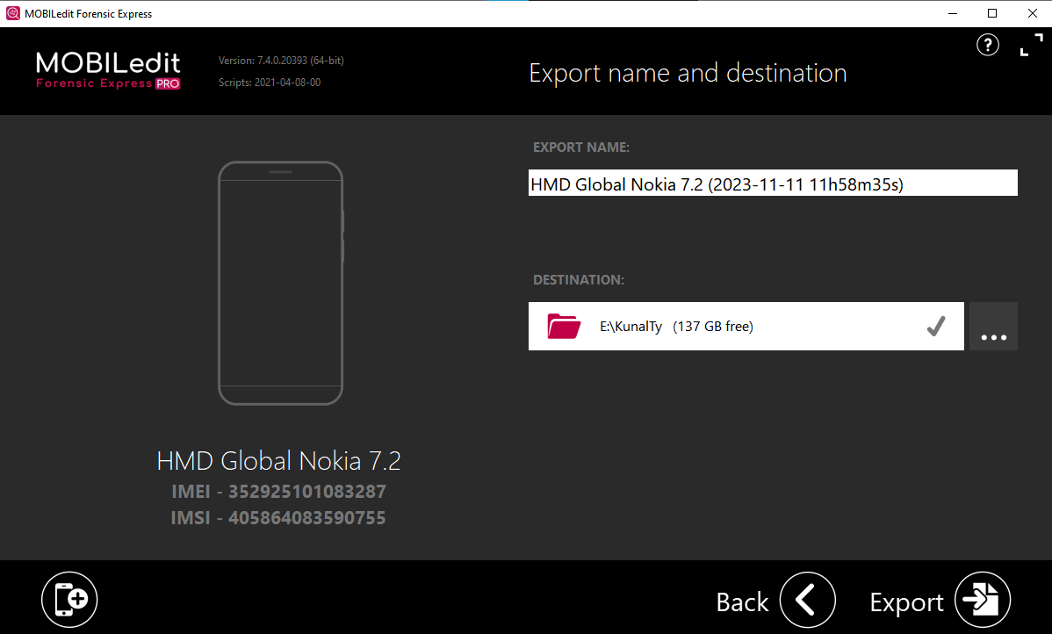

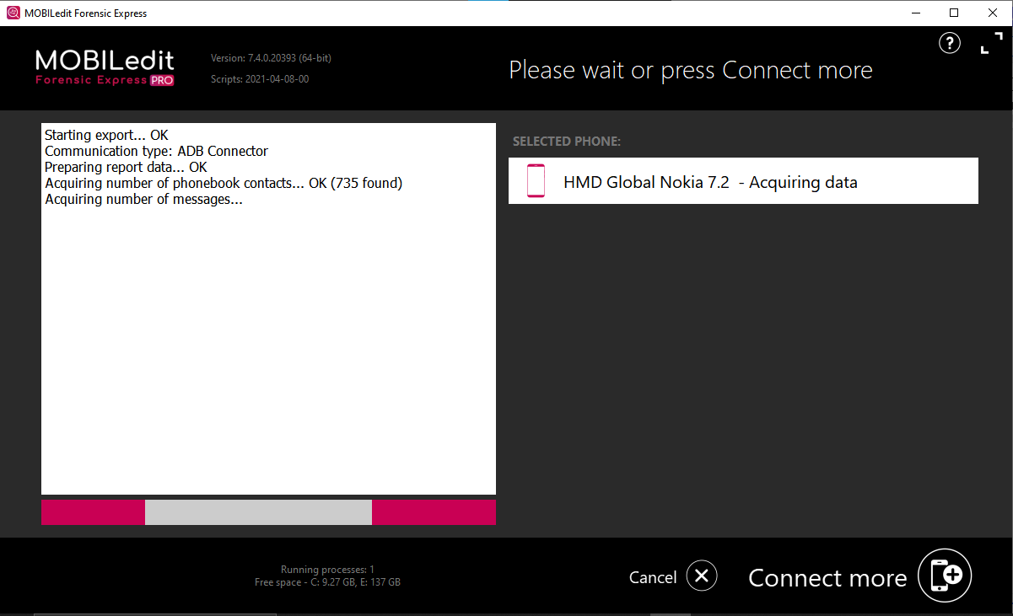

**Start BackUp**

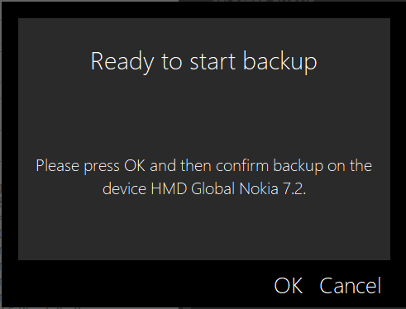

**Creating Reports**

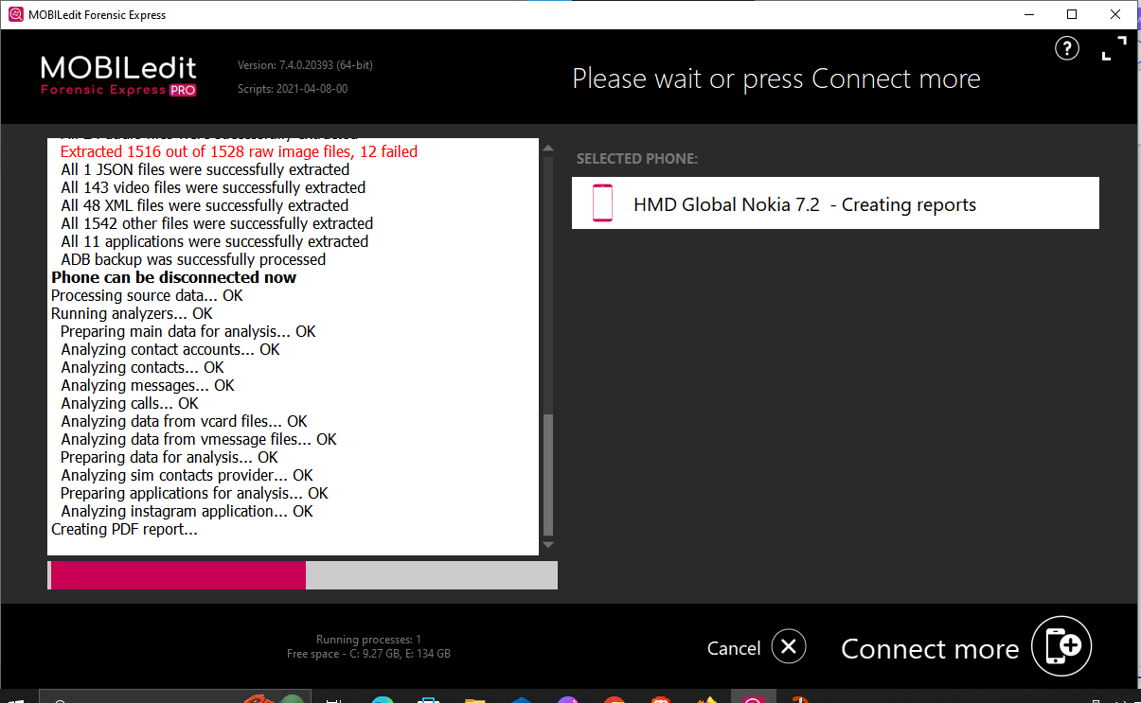

**Extraction complete**

